Customer Meeting Date: undecided due to COVID-19, the client is busy, will demo in teration 2

Design Diagram:

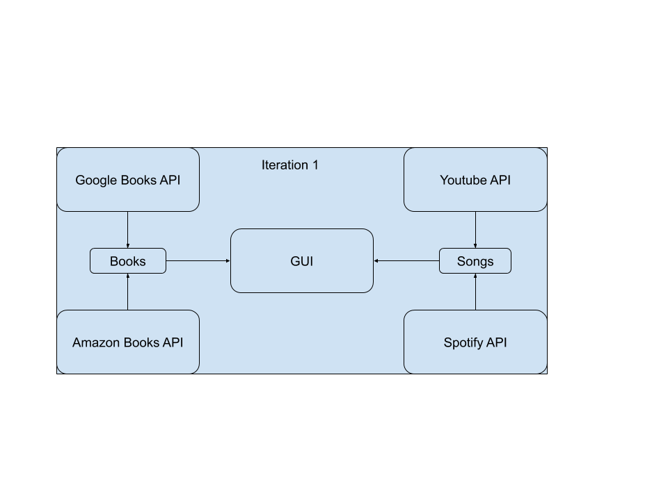

Cannot implement Barnes & Nobles API because it’s a private API (details below)

|  |  |
| --- | --- |
| Sicong Huang | SCRUM master, product owner, code review and merge |
| Aditya Atul Vijayvergia | Amazon Books API |
| Chen Liang | GUI |
| David Qin | YouTube API |
| Joseph Cisneros | Spotify API / Barnes Noble API |
| Fengqiao Wang | Google Books API |

Due to COVID-19, our team has a slow start, We can’t get all of the code merged and have no code test / BDD test yet. The GUI is already functional but has no data input.

Pivotal Tracker: <https://www.pivotaltracker.com/n/projects/2437225>

GitHub repo: <https://github.com/Innoversa/Law-School-Copyright>

More description below:

## Graphical User Interface (GUI)

For this iteration a prototype of GUI has been created. Detailed information, such as settings and choices in the user interface, will be modified based on what can be scraped using API. A screenshot of user interface is as the following:

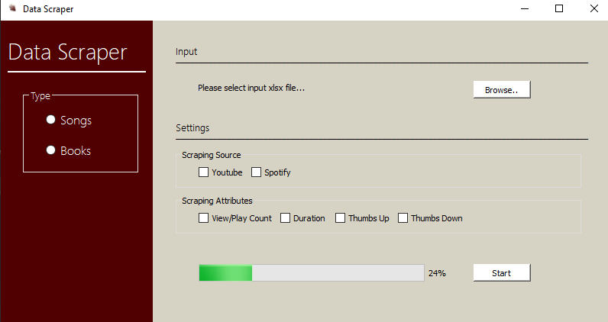

More collaborative works will be done in the future iterations to connect program functionality with user interface.

## Youtube API

The Youtube API provides tons of features and support for just about anything youtube related. This supports various languages including python. In our project, we will mainly use this API for its basic functionalities of searching for videos and gathering related statistics such as likes and views.

As of now, this portion of the project has the basic functionalities to gather views for one video. Our next step is to handle multiple requests (such as being fed an excel sheet) and smoothly process that. In future iterations, we hope to support multiple requests and integrate this with the mentioned GUI. One noteworthy issue is the reliance of the Google API backend, which needs some setup. In our cause, it’s not set up fully and will have security warnings.

Google Books API

It enables you to add the Google Books features programmatically to our application. With the API, we can allow users to search and browse the list of books relevant to their queries, manage their own bookshelves, and view details about a book, including price, metadata, and availability.

It is also available in python and out of all these features, we only need to get the pricing of the books

## Amazon Books API

The Amazon books API gives a ton of information about almost all books from their database. This includes both – general information about the books (Title, author, manufacturer, publisher, publication date, etc.) and information specific to amazon (Price of book, offers on the book, product URL, customer reviews, etc.).

The API allows searching based on various book features like book ISBN, search by author, manufacturer, theme, etc). Searching a book with the ISBN is the best approach for the application as it returns the specific book with all relevant information.

It also provides top lists, newest versions and other similar books. The API does not tell us about the number of copies sold.

It is just a link with some info so it can be used with any language.

## Spotify API

The Spotify API provides a lot of data for each song in what they call a “Track” JSON object, which provides data for the “popularity” of the song. The popularity is described as: The value will be between 0 and 100, with 100 being the most popular. The popularity of a track is a value between 0 and 100, with 100 being the most popular. The popularity is calculated by algorithm and is based, in the most part, on the total number of plays the track has had and how recent those plays are. Generally speaking, songs that are being played a lot now will have a higher popularity than songs that were played a lot in the past. Duplicate tracks (e.g. the same track from a single and an album) are rated independently. Artist and album popularity is derived mathematically from track popularity. Note that the popularity value may lag actual popularity by a few days: the value is not updated in real time.

The API information is at

<https://developer.spotify.com/documentation/web-api/reference/tracks/get-track/>

Unfortunately for some reason the Spotify API does not provide the play count of each track.

<https://github.com/spotify/web-api/issues/70>

## Barnes&Noble API

The Barnes & Noble API is private, and is only available to their partners & affiliates.

<https://stackoverflow.com/questions/7662886/where-can-i-find-documentation-for-barnes-and-noble-search-api>